|  |
| --- |
|  |
| Software Design Document (SDD) |
| F:\Google\Client Documents\Iman\logo_text_aligned.jpg |
|  |
| **Revision 1.0** |
| **September 15, 2016** |

|  |
| --- |
|  |

Table of Contents

[1. Introduction 4](#_Toc462080419)

[1.1 Scope 4](#_Toc462080420)

[2. System Requirements 4](#_Toc462080421)

[3. Specifications 5](#_Toc462080422)

[Technical and Software Specification 5](#_Toc462080423)

[4. Module Design 6](#_Toc462080424)

[( I ) User Interface Design 6](#_Toc462080425)

[( II ) Authentication System 6](#_Toc462080426)

[• Login 6](#_Toc462080427)

[• Register 6](#_Toc462080428)

[• Forget Password 7](#_Toc462080429)

[• Change Password 8](#_Toc462080430)

[( III ). Manage Users 8](#_Toc462080431)

[• Create User 8](#_Toc462080432)

[• Edit User Details 8](#_Toc462080433)

[• Delete User 8](#_Toc462080434)

[• Enable / Disable User 8](#_Toc462080435)

[( IV ) Site Usage Statics 9](#_Toc462080436)

[( V ) Manage Bot Templates 9](#_Toc462080437)

[• Register New Bot Template 9](#_Toc462080438)

[• Buy Bot Templates 9](#_Toc462080439)

[• Integrate Bot with Other Platform 9](#_Toc462080440)

[• Update Bot Template 9](#_Toc462080441)

[• Delete Bot Template 9](#_Toc462080442)

[• Search Bots 10](#_Toc462080443)

[• Enable / Disable Bot (Show On Site Or Not ) 10](#_Toc462080444)

[(VI) Sentiment Analysis 10](#_Toc462080445)

[(VII) Multilanguage Module Integration for Chatting 10](#_Toc462080446)

[5. Use Cases For Web And Mobile 10](#_Toc462080447)

[( I ) Site Administrator 10](#_Toc462080448)

[1. Manage Users 11](#_Toc462080449)

[2. Site Usage Statics 11](#_Toc462080450)

[3. Manage Bot Templates 11](#_Toc462080451)

[4. Manage Clients 11](#_Toc462080452)

[5. Manage Payments 11](#_Toc462080453)

[6. Bot Permissions 11](#_Toc462080454)

[7. Special Admin Privileges 12](#_Toc462080455)

[8. Manage Orders 12](#_Toc462080456)

[9. Sentimental Analysis 12](#_Toc462080457)

[( II ) Bot Administrator 12](#_Toc462080458)

[1. Manage Payments 12](#_Toc462080459)

[2. Manage Orders 12](#_Toc462080460)

[3. Site Usage Statics 12](#_Toc462080461)

[4. Manage Bot Templates 12](#_Toc462080462)

[( III ) End User 13](#_Toc462080463)

[Technical Concerns & Standards 13](#_Toc462080464)

[• High End Security For Web API’s 13](#_Toc462080465)

[• Automated Testing 13](#_Toc462080466)

[• Sentiments Analysis Detection Scenario’s 13](#_Toc462080467)

[Scenario 1 13](#_Toc462080468)

[Scenario 2 14](#_Toc462080469)

[• Technical Concerns 14](#_Toc462080470)

[Bot Creation 14](#_Toc462080471)

[Sentimental Analysis 14](#_Toc462080472)

[Site Usage Statics 14](#_Toc462080473)

[Use Case Diagram ( I ) Site Administrator Use Case 15](#_Toc462080474)

[( II ) Bot Administrator Use Case Diagram 16](#_Toc462080475)

[( III ) End User Use Case Diagram 17](#_Toc462080476)

[Sequence Diagrams 18](#_Toc462080477)

[( I ) Buy Bot Sequence Diagram 18](#_Toc462080478)

## 1. Introduction

### 1.1 Scope

This Project involves Web Application, iPhone Application and Android Application That focuses on Building Bots . These Bots will interact with Different Third Party Web Api’s In Order to Fulfill User’s Request . Bots Also Needs to Be integrated with Social Media Application Such As Facebook , Skype , Slack etc.

Bot Administrators Can Buy Bots To Server Users. Users Can Interact With Bots like they are interacting with a Real Support Member that is processing User’s requirements.

Project Involves Bot to Search Products from E-Commerce Websites as per User’s Request. In this Case Bot Will Interact with Web API’s That involves EBay API , Amazon API , Aliexpress and Get Demanded Product For User with List of Prices from These Websites .It will also Allow User To Buy Product From These E-Commerce Website Using These Bots .

Project Allows User To Get Updates and Notifications From Bots. Project also Involves Performing Sentiment Analysis and Maintaining Chat History for Users. It Also Allows you to Start and Stop Getting Notifications From Bot.

Project Involves Appointment Bot that can set / get Appointments On Google Calendar / Office 365 Calendar.

## 2. System Requirements

Following are System Requirements for Web Application

1. Microsoft Windows 8 Or Higher
2. .Net Framework 4.6.1 Or Higher
3. JavaScript Enabled Latest Web Browser like Google Chrome, Mozilla Firefox etc .

## 3. Specifications

### Technical and Software Specification

Following were the **Technical Specification** setup for the Project Development.

1. Microsoft Windows 8 or Higher

2. Visual Studio 2015

3. Microsoft SQL Server On Windows Azure .

4. Visual Studio 2010 Extensions /nugget packages with (Productivity Tools, Unity).

5. Team Foundation Server

6. Test Accounts For Api's We are Integrating

7. .Net Framework 4.6.1

Following were the Development **software Specification** for the Project.

1. ASP.NET MVC 5 Razor Approach with Unity

2. Generic Repository Pattern With UnitOfWork

3. Strong Object Oriented Project Structure with Layer of Interfaces.

4. SOLID & Dry Principles implementation

5. Microsoft Entity Framework 6 with Code First Approach

6. Version Control With Microsoft Team Foundation Server

7. Logging With ELMAH

8. Linq

9. Web API With JSON Result

10. Encrypted Token Based Based Security for API

11. SSL Support For Web for Providing Encrypted Communication Across Web Pages

## 4. Module Design

( I ) User Interface Design  
  
1. This includes User Interface Design For Authentication Module. User Interface Design will Follow Usability Principles that will make User Interface Easy to use and Self Explanatory to User Using the System .

2. User Interface Design will be Responsive So that It will Adapt all Screen Sizes Including Different Desktop Screen Size as well as Mobile Screen size .  
  
3. For Web Responsive Design we will be using Twitter Bootstrap 3.3  
  
4. We Can Use below Website to Check and Test Responsiveness of Website -  
[**http://www.responsivetest**.net/](http://www.responsivetest.net/)

### ( II ) Authentication System

* Login   
    
  1. Login Will Consist of Necessary Fields like Username / Email and Password For Authenticating Their Validity to System.  
    
  2. Max Login Attempts Will be 3 , After 3 Login Attempts Captcha will be shown to User.   
    
  3. After 3 Incorrect Login Attempts, An Email Will be sent to User Email Regarding Somebody Trying To Access Their System, If its not him User can change Account Credentials .So that if some person trying to hack User Account Account Holder is notified about that. Maximum 5 Incorrect Login Attempts will be allowed after That Account Will Suspended for 1 day User Can Contact Site Admin to Re-Login to Website If User Needs Account to be Action before 1 day. After 1 day account will be automatically active.  
    
  4. In order to Prevent CSRF (Cross Site Request Forgery) Anti-Forgery Token Will be Used.
* Register  
    
  1. User / Client Registration Requires User’s Email. User’s Email will also be used For Forget Password and Change Password Purposes.  
    
  2. User Will be Presented With Buttons Options To Choose Whether User want to Register as a End User To Use the Bots Or As a Client and Want To Buy Bots .  
    
  3. If User’s Chooses To Be a Client Then After Regsiteration Process User Must Need to Select Membership Plan In Order To Buy a Bot in the System. After Successful Bot Administrator Registration / Client Registration When Bot Administrator logged In To System Bot Administrator will be presented with membership Plans to Choose In Order to User Other Bot Administrator Options To Build Bots .   
  This Option will be modified as per Your View on this option   
    
  3. In Order to Protect Registration Process from XSS Attacks and CSRF Attacks Anti Forgery Tokens and Captcha will be Used So That Website Remain Secure From Different Type of Hacking Attacks to make Load / Stress on System  
    
  4. After Successful Registration User / Client will be Sent Account Confirmation E-Mail. With a link sent to User’s Registered Email. Only After Account Confirmation is done User will be able to Access / Login In To his/her Account.  
    
  5. After User’s Registration User / Client will be Sent Welcome To Website Message With Format Text Along with that User will be presented with Different Website Features that User / Client Can Use in Website . These Features will be depending on Account Role Whether it is Client Or User.
* Forget Password  
    
  1. Change Password Request Will Initiate with Providing Registered E-Mail ID . System will first check whether this Email ID Exist in System  
    
  If Provided Email ID does not exist then user will be provided with message to recheck Email ID Provided. If Provided Email ID Exist in System Then An Email Will be sent to Provided Email ID with Binary Coded Encrypted Token. This Encrypted Token Will Expire After 24 hour or As Per We Decide.  
    
  2. For Security Purpose Maximum Change Password Attempts Allowed Per Day will be 3. An Email will be sent to User’s Email Regarding Max Attempts For Change Password Reached In Order to Notify and Confirm whether its Genuine User making Change Password Request or not.
* Change Password  
    
  1. Change Password Will be Accessible to Logged In Users. It will ask User For Old Password , New Password and Confirm Password . It Old Password Matches with User’s Current Password then It will change it will New Entered Password

### ( III ). Manage Users

* Create User  
  Creating New Users whether it is User / Client is created in system through Registration Process Explained in Authentication Module . Its only way to create Users in the System. Admin Can Manage Other details that include Disabling User or Deleting User Details .User Schema Will be available in Database Schema Definition Section
* Edit User Details  
  Edit User Details Section Will Only Be Available To Logged in User . As it may contain Personal Details of the User So No Other That User Himself Can Change Details Of User. User Can Change All Details Other Than User ID that is auto generated For Each User of the System
* Delete User  
  Delete User Includes Deleting User Permanently From the System .As User may be referenced in Other Tables of System So User Will not be Physically Deleted From User Instead We will be having IsDeleted Fields In Data Base for Users Table When That Key is Set to 1 User will be Identified as Deleted User and Will not be Able to login to system and Cannot be Accessible and included in any Sections of Website. User will not be available in any statics or List .
* Enable / Disable User  
  Enable / Disable User Allows To Enable / Disable User To Login To System. In this scenario Users data will be accessible and used in system and will show in Users List or Statics But User will not be able to Login

### ( IV ) Site Usage Statics

1. In order to track usage statics we will be using JQuery Ajax Request that will be automatically triggered With Use of Ajax there will be no need to refresh page.   
  
2. Usage Statics will be tracked and Save to Database Tables with IP Addresses , Country ,User ID , Date , Time , Bot ID.

3. It will include Users Login Tracking , Client Login Tracking , Bot Usage By Each Bot Wise . Bot Usage By Country Wise , Bot Usage by Date and Time Wise. Payments Statics, Payments Statics Client Wise , Payment Statics Bots Wise , Users / Client Registrations statics Today Wise - This Week Wise - This Month Wise - Custom Range Wise .User Sentiments Statics Bot Wise – User Wise Per Bot – Date Wise – Month Wise , Payment Graphs Statics , Bot Sale Statics Graph.

### ( V ) Manage Bot Templates

* Register New Bot Template  
  It Includes Adding New Bot To System. Bot Template Definition will be Available in Database Schema Definition Section.
* Buy Bot Templates  
  1. This Section will include E-Commerce Section To Buy Bots with Payment API Integration For Checkouts.

2. This Section is available for Bot Administrators that Can Explore / Search Available Bot and Buy bots online by using Using Payment Gateway that will be integrated in the system.

* Integrate Bot with Other Platform
* Update Bot Template  
  1. It includes Update the Details of Bot Template As Per Schema Definition of Bot. Bot
* Delete Bot Template  
  In Include Disabling Bot Template, In that way it will act as not available to Bot Administrators and End Users and only available to End Users.
* Search Bots  
  Search Bots include the search / Filters for Exploring the Available bot it can configured using Filter by Name , Filter by High usage ( Low – high ) , Filter by Cost ( Low – high ), Filter By Date ( Newly , Latest ) etc.
* Enable / Disable Bot (Show On Site Or Not )  
    
  1. It includes Features For Enabling / Disabling Bot . There are many factors to do so . We can disable a Bot if it contains some abusive language integrated or Its having Low Rank in Sentimental Analysis or some other valid reason  
    
  2. This section will be involved in Bot Dashboard UI. Only Site Administrator and Bot Administrator are having Rights to enable / Disable Bots. After disabling bot No User Can Use it Until it is again Enabled . A Message will be Sent As Notification Automatically when this bot got disable to all Users Using this Bot Regarding Disabling of This Bot.

### **(VI)** Sentiment Analysis

(VII) Multilanguage Module Integration for Chatting

## 5. Use Cases For Web And Mobile

**There are Three Actors In Systems**

* Site Administrator
* Bot Administrator
* End Users

### ( I ) Site Administrator

Site Administrator is the Admin of Website that has Full Access to Each and Every Functionality of Website. Site Administrator Is available with Complete Access To Users Database, Managing All Bots Available in System. It can Perform Actions That May Include Adding New Bots To user, Enable Bots For Clients, Managing Bot Usage Statics, Enabling / Disabling Users. Site Administrators Have Access to Complete Website Contact including Actions that may include changing Website Content, Enabling / Disable Site Modules according To Different User Roles. Below is list of Actions that Site Admin Can Perform:-

### 1. Manage Users

* Create User
* Edit User Details
* Delete User
* Enable / Disable User

### 2. Site Usage Statics

* Usage Statics By Bot
* Usage Statics By Users
* Usage Statics By Date ( Month Wise, Week Wise, Year Wise)
* Usage Statics By Sale ( High Sale Bots, Low Sale Bots )

### 3. Manage Bot Templates

* Register New Bot Template
* Integrate Bot with Other Platforms
* Update Bot Template
* Delete Bot Template
* Start / Stop Bot

### 4. Manage Clients

* Client List
* Search Clients
* Client Details With Bot Purchases

### 5. Manage Payments

* Payments List
* Search Payments

### 6. Bot Permissions

* Manage Permissions / Roles For Users

### 7. Special Admin Privileges

* View Chat Messages
* Stop Any Running Bot
* Answer On Behalf Of Bot

### 8. Manage Orders

* View Orders List
* List Paging & Search Orders By Client, Website etc.

### 9. Sentimental Analysis

* Show Sentiment Analysis For Users Chat

### ( II ) Bot Administrator

### Manage Payments

* Payment History
* Payment Notifications
* Buy New Bots

### Manage Orders

* View Orders List
* List Paging & Search Orders By Client , Website etc

### 3. Site Usage Statics

* User Interface Design
* Usage Statics By Bot
* Usage Statics By Users
* Bot Usage Statics By Date

### 4. Manage Bot Templates

* Buy Bot Templates
* See Bot Info
* Search Bots
* Integrate Bot with Other Platforms
* Update Bot Template
* Delete Bot Template
* Enable / Disable Bot

## ( III ) End User

* End Users Can Chat Using Bots
* End Users Stats Will Be Saved To Database For Usage Statics Module
* End Users Will Be Presented with Authentication Functionality. That May Include :
  + Login
  + Register
  + Forget Password
  + Change Password
  + User Chat History With Bots
  + Notification System That Will Notify User With Different Notifications / Updates Form Bots
  + Search Bot
  + See Bots Info
  + Start / Stop Bot Notifications

## Technical Concerns & Standards

### High End Security For Web API’s

For Providing High Security to Web API We Will Apply OWIN / Katana Token Based Authentication to API. User Must need to pass token With Call To API. We Can Handle Token Along with Expiration Time

### Automated Testing

For Implementing Automated Testing We Can Use Unit Testing Framework NUnit To Build Test suites .

### Sentiments Analysis Detection Scenario’s

For Detecting Sentiments we can Use below Logic -

### Scenario 1

If user does not respond to bot in a time span of 10-15 or as we finalize then Bot Can Stop the Chat or Close Chat. Bot can keep asking user to give reply within that time span

### Scenario 2

For Detecting Sentiments We Need to User We Need to Detect Some Set of Keywords that may exist in User’s Abusive Talk or Anger Talk only in that we can detect User’s Sentiments

### Technical Concerns

Bot Creation: Foremost Technical Concern Will Be How We will be Implementing Dynamic Bots. As Per Project Requirements we need Bots to be dynamically Created That Defines Bot Response to User.

Sentimental Analysis: Sentimental Analysis is another major concern . We Need To Make Algorithms that will check Conversations to Track Users sentiments Then They Will Fire Events To Start and Stop Bots Depending on Sentiments of Users in Chat .

We are planning to Set specific Set of Keywords that will identify sentiments of Users and Can Call Service or Events To Perform Specific Function Corresponding to Action.

Site Usage Statics**:** We need to implement Tracking in Various Modules of Website to get Site Usage Statics as well as Bot Usage Statics .We Need To Make Separate Tracking API For Website that will be called through Ajax Calls to Save Different Types of Usage Statics . It may include :-

* + Each Bot Usage Statics
  + Each Bot Payment Statics
  + Sentimental Analysis Statics For Bot

## Use Case Diagram **( I ) Site Administrator Use Case**

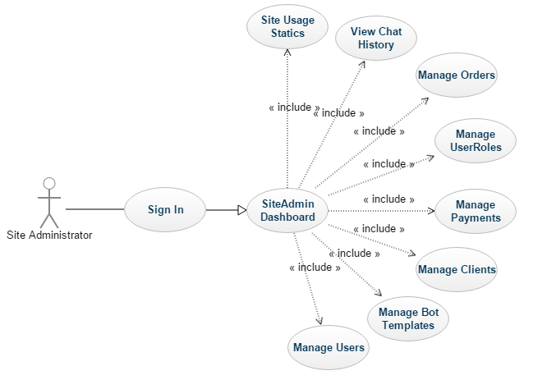

Figure : Site Administrator Use Case Diagram

### ( II ) Bot Administrator Use Case Diagram

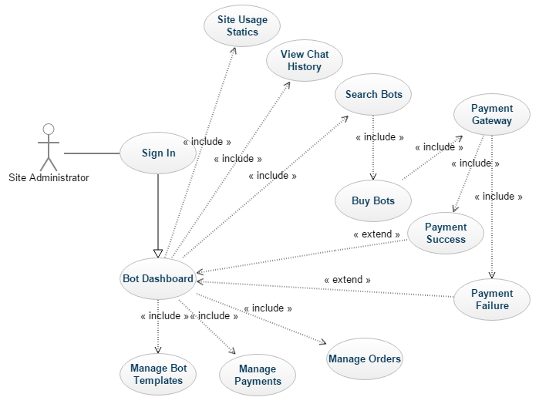

Figure2: Bot Administrator Use Case Diagram

### ( III ) End User Use Case Diagram

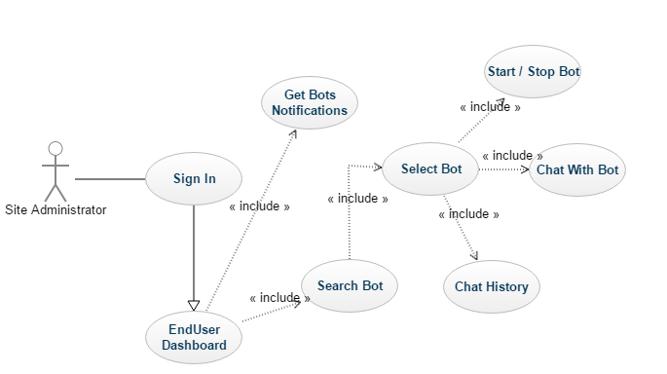

Figure3: End User Use Case Diagram

## Sequence Diagrams

### ( I ) Buy Bot Sequence Diagram

